*Addressing Student Behavior*

Reproducible Forms

The forms in this file are model forms and tools that districts and schools may use at their discretion—they are not mandated by the state. They are also copyright free and no permission is needed to reproduce them for noncommercial purposes. If these forms are included in another non-profit publication, then the citation should read as follows:

Some information in this document was adapted from *Addressing Student Behavior: A Guide for All Educators,* which is a copyright-free technical assistance manual prepared by the New Mexico Public Education Department, Quality Assurance Bureau, Fall 2010. [www.ped.state.nm.us](http://www.ped.state.nm.us)

**Functional Behavioral Assessment (FBA) Tools**

Scatterplot 2

ABC Observation Form 3

Sample Interview Script—Teacher/Parent 4–5

Sample Interview Script—Student 6

Data Triangle Chart 7

FBA Hypotheses Template 8

FBA Report Form 9–11

**Behavioral Intervention Plan (BIP) Tool**

BIP Form 12–14

Description: j0088924

|  |  |  |  |  |  |  |  |
| --- | --- | --- | --- | --- | --- | --- | --- |
| **Scatterplot**  **Student:__________________________________ Grade: ______ School: __________________________**  **Date(s): _____________________ Observer: __________________________________________________**  **Behavior of Concern: _____________________________________________________________________**  **________________________________________** **Additional relevant information: __________________**  **_______________________________________________________________________________________**  **Code used (if any): ________________________________________________________________________** | | | | | | | |
| **Setting or Class** | **Times or Intervals** | **Day/Date** | **Day/Date** | **Day/Date** | **Day/Date** | **Day/Date** | **Total Times Observed** |
|  |  |  |  |  |
|  |  |  |  |  |  |  |  |
|  |  |  |  |  |  |  |  |
|  |  |  |  |  |  |  |  |
|  |  |  |  |  |  |  |  |
|  |  |  |  |  |  |  |  |
|  |  |  |  |  |  |  |  |
|  |  |  |  |  |  |  |  |
|  |  |  |  |  |  |  |  |
|  |  |  |  |  |  |  |  |
|  |  |  |  |  |  |  |  |
|  |  |  |  |  |  |  |  |
|  |  |  |  |  |  |  |  |
|  |  |  |  |  |  |  |  |

**Observation Notes**

(e.g., specific circumstances under which the behavior occurred, particular antecedents that triggered   
the behavior, times/conditions during which the behavior does not occur, patterns observed, etc.)

_________________________________________________________________________________

_________________________________________________________________________________

_________________________________________________________________________________

_________________________________________________________________________________

_________________________________________________________________________________

**ABC Observation Form**

Student:__________________________________ Grade: ______ School:

Date(s): _____________________ Observer:

Behavior of Concern:

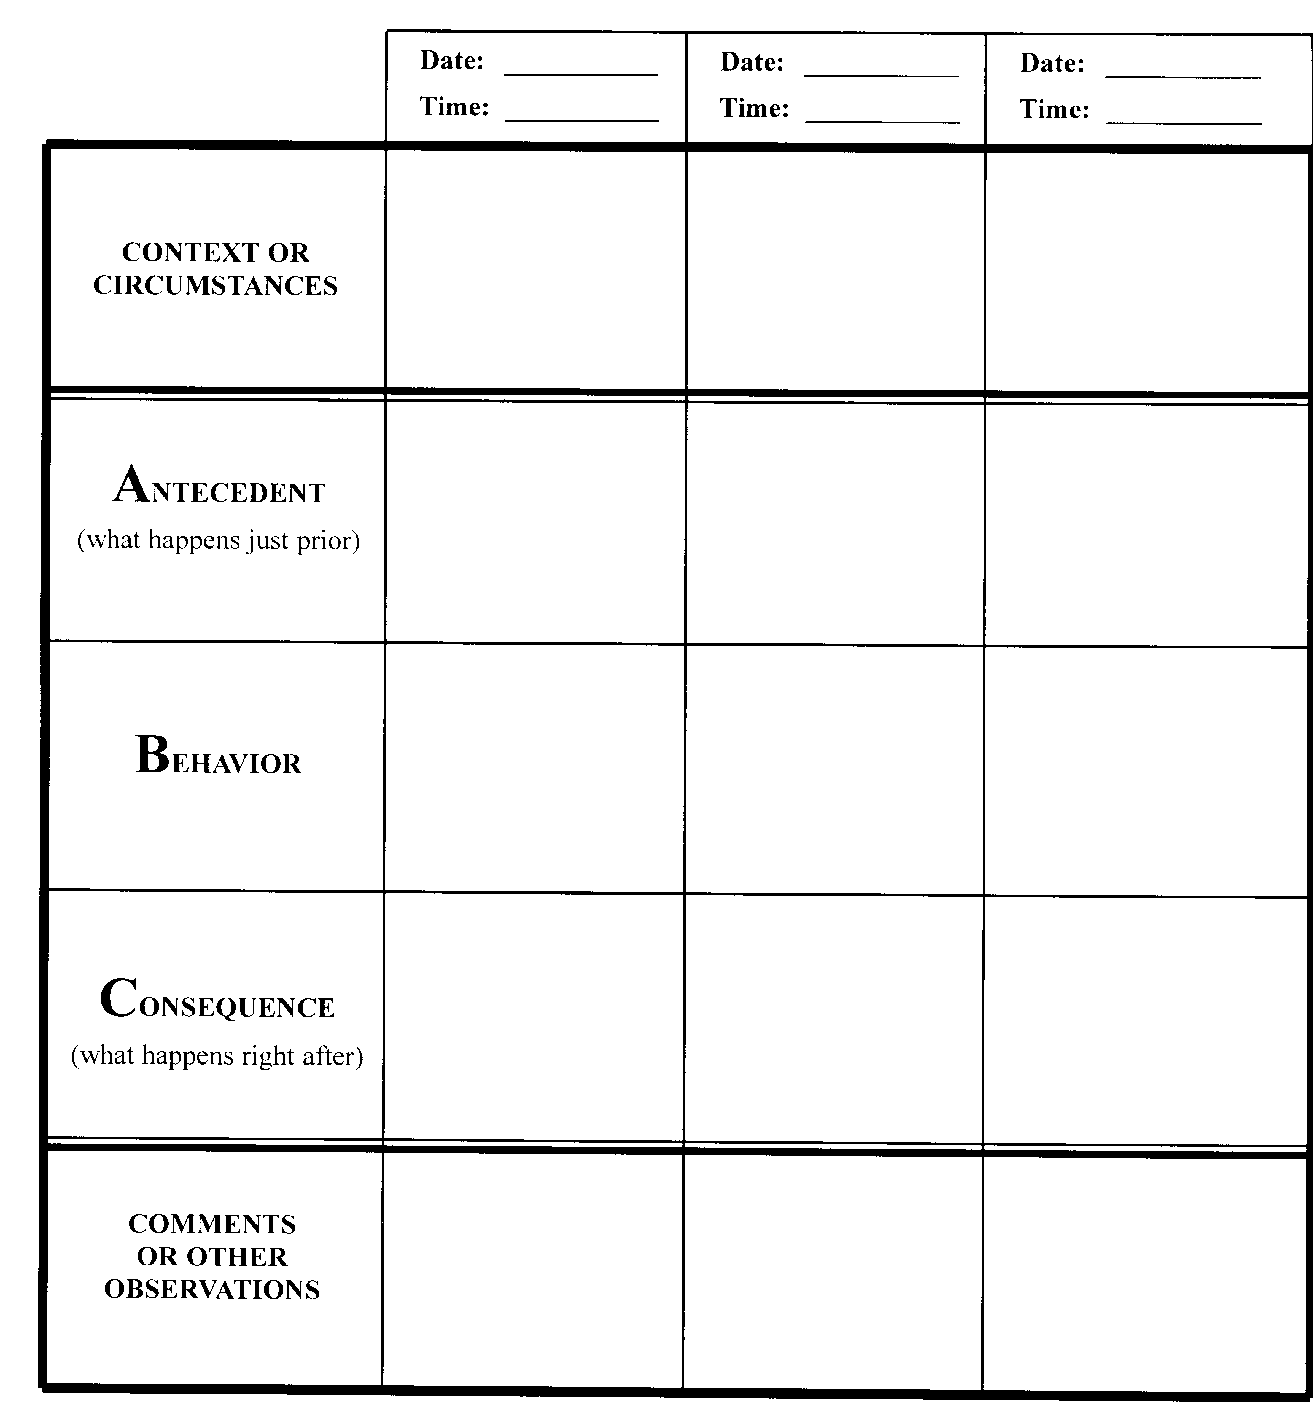

**Sample****Interview Script—Teacher/Parent**

Concern has been expressed about _________________’s behavior, specifically ________________________________. We are gathering information for the purpose of identifying possible reasons for the behavior so that we are able to develop and recommend appropriate interventions.

**Q**. In what specific settings or under what conditions do you observe the behavior?

A.

**Q**. Are there settings, conditions, or situations in which the behavior does NOT occur?

A.

**Q**. Characterize your observation of the frequency, intensity, and duration of the behavior.

A.

**Q**. Who is present when the behavior occurs?

A.

**Q**. Which of these, if any, typically precede the behavior?

*directive or request from authority  provocation from peers  academic activity*

*unstructured setting  transition time  certain time of day*

Describe the activity or interaction that takes place just prior to the behavior.

A.

**Q**. Which of these, if any, typically immediately follows the behavior?

*behavior is socially reinforced by peers  receives attention  gets corrective feedback*

*is removed from the setting  privileges are withheld  negative consequence*

*no consequences or behavior is ignored  no obvious consistency  other*

Describe the typical result of the behavior and consequence of it.

A.

**Q**. Are there other behaviors that usually occur along with the problem behavior?

A.

**Q**. What positive reinforcers have you used with this student and how effective were they?

A.

**Q**. What negative consequence have you used with this student and how effective were they?

A.

**Q**. For what reasons might the student be showing this behavior? (e.g., to get, control, or avoid something)

A.

**Q**. In your opinion, what would be an acceptable way for the student to achieve the same outcome?

A.

**Q**. Do you feel that this student does not “know how” to achieve his needs using appropriate behavior (can’t). Or, does the student know how to behave differently, but consistently chooses not to (won’t)?

A.

**Q**. What other insight can you offer about this student or the behavior that might assist us in developing appropriate, effective interventions? (Parents: any health, eating/sleeping habits, other patterns?)

A.

**Notes:**

**Sample****Interview Script—Student**

We are gathering information in order to better understand what goes on in and out of the classroom. We would like to know and consider the students’ point of view as well as the adults’. We need your help to get an accurate “picture.” Please answer these few questions as openly and honestly as possible.

**Q**. Do you think that what goes on outside of school affects how a student works and behaves in class? How (give example)?

A.

**Q**. What about you? What is happening in your life outside of school that affects you in school?

A.

**Q**. Most students are bothered by someone or something that goes on at school. What bothers you?

A.

**Q**. Have you recently been punished or reprimanded for something you did in school? Why?

A.

**Q**. How about (*identify the target behavior*)? What was going on the last time or other times you  
 behaved that way? What happened just before or what caused you to behave that way?

A.

**Q**. What usually happens right after you or another student behaves differently than expected to?

A.

**Q**. What do you think was expected of you? Was the judgment fair or not, and why?

A.

**Q**. How do you feel about (*specific subject, teacher, students, situation*)?

A.

**Q**. How do you think (*specific teacher, students, other person/people*) feels about you?

A.

**Q**. What happens when you DO do exactly as you are expected? What SHOULD happen?

A.

**Q**. What consequence has that behavior had for you? What SHOULD the consequence be?

A.

**Q**. Can you think of any times or situations in school that you would really avoid if you could?

A.

**Q**. Can you think of anything that you wish would happen that doesn’t happen often or at all?

A.

**Q**. Name one or two things you wish were different about school.

A.

**Q**. Name one or two things you wish were different outside of school.

A.

**Q**. Name one or two things you wish were different about yourself.

A. __________________________________________________________________________

**Data Triangle Chart**

Student:___________________________________ Grade: ______

Dates: __________________________

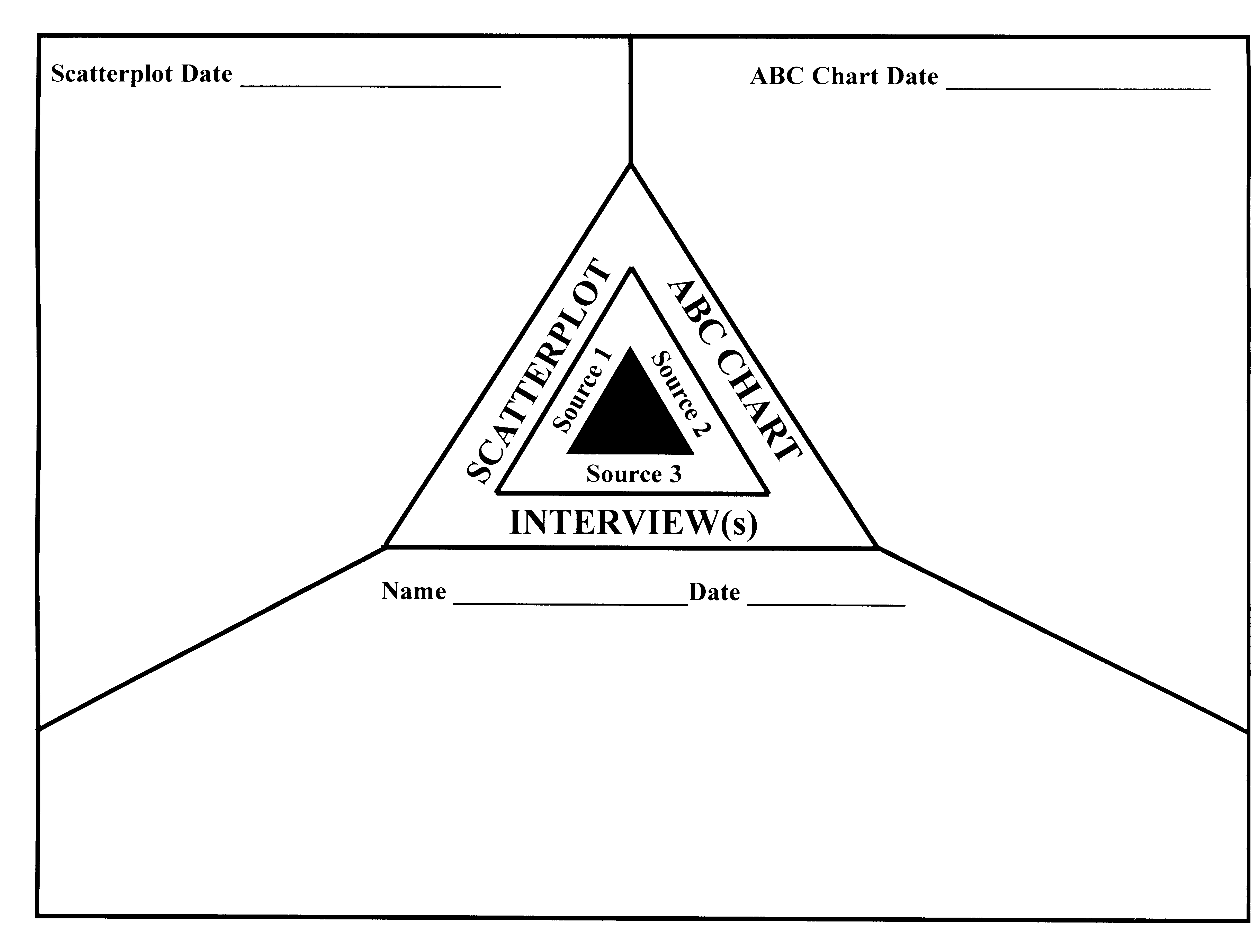Behavior of Concern: _______________________________________________________

* **Precipitating Events** (conditions/circumstances under which target behavior occurs):

* **Functions that Maintain the Behavior** (what he/she gets, controls, or avoids as a consequence of the action):

* **Deficit(s)** (skill or performance):

**Interpretation Summary**:

________________________________________________________________________

## Functional Behavior Assessment (FBA) Hypothesis Template

The success of the developing behavioral interventions to be for a student depends on the accuracy of the efforts to define and evaluate the problem. Persons performing the FBA may want to use this template as a tool to synthesize their findings before including them on the last page of the FBA Report Form. See page 21 of *Addressing Student* *Behavior* for a sample.

______________________________________________________________________

*When (X-target) behavior occurs, it is usually in the context of (X-where and/or when) and preceded by (X) trigger(s).*

*The student’s response is (X-describe in specific behavioral terms).*

*The result of the behavior is usually (X), which serves to (X-describe “pay-off” ).*

*The function and/or purpose of this response is likely to be a (X-to get/seek…or to escape and/or avoid…).*

*The behavior appears to be a (X-skill deficit or performance deficit) because (X).*

## Functional Behavioral Assessment Report

Student Name: ___________________________________________________ Date:

School: ____________________________________________Grade:___ Age: ____Gender:

A **Functional Behavioral Assessment** (FBA) is done when a student’s behavior interferes with his or her learning or the learning of others. Its purpose is to identify why a behavior is happening so that the SAT, Section 504, or IEP team can develop appropriate interventions.

**1. Sources of Information ✓Check** sources to be used; **Circle E** ifreviewing **existing** data,

**Circle N** if **new** data is needed*\**

______ **E N** Anecdotal information provided by parents

______ **E N** Parent interviews

______ **E N** Diagnostic evaluation(s) done by _________________________________

______ **E N** Independent diagnostic evaluation(s) ______ **E N** Tier 1 Interventions

______ **E N** Classroom/school observation(s) ______ **E N** Student interview

______ **E N** Interview with other professionals ______ **E N** Teacher interview(s)

______ **E N** Behavior Rating Scales ______ **E N** Discipline records

______ **E N** IEP(s) and IEP progress reports ______ **E N** Attendance records

______ **E N** Assessment scores ______ **E N** Grades/report cards

______ **E N** Data collection tools:

______ **E N** (other)

***\*Note: Written parent consent is necessary for an FBA that is part of a special education initial evaluation or reevaluation. For students without disabilities, written parental consent is highly recommended.***

**2**. **Identified Problem Behavior (*what the student is doing or not doing)***

**State setting, frequency, duration, intensity, and severity.**

A) Observed and/or reported by  *School staff  Parents  Other*

B) Observed and/or reported by  *School staff  Parents  Other*

C) Observed and/or reported by  *School staff  Parents  Other*

**3**. **Events that Typically Precede the Problem Behavior (school setting)**

**Check all that apply, then describe:**

*directive or request from authority  provocation from peers  academic activity*

*unstructured setting  transition time  certain time of day*

*no obvious circumstance  other*

*____________________________________________________________________________*

*__________________________________________________________________________*

*_____________________________________________________________________________*

*_____________________________________________________________________________*

*_____________________________________________________________________________*

*_____________________________________________________________________________*

**4**. **Events that Typically Follow the Problem Behavior (school setting)**

**Check all that apply, then describe:**

*behavior is socially reinforced by peers  receives attention*

*gets corrective feedback*

*is removed from the setting  privileges are withheld*

*gets negative consequence*

*no consequences or behavior is ignored  no obvious consistency  other*

*_____________________________________________________________________________________*

*_____________________________________________________________________________________*

*_____________________________________________________________________________________*

*_____________________________________________________________________________________*

*_____________________________________________________________________________________*

*_____________________________________________________________________________________*

**5**. **Effectiveness of Interventions on Behavior**

Describe what **positive reinforcers** have been tried and rate their level of effectiveness from 0­-5, with 5 being very effective and 0 being completely ineffective. *Example: special activities (4); compliments (1)*

*_____________________________________________________________________________________*

*_____________________________________________________________________________________*

*_____________________________________________________________________________________*

*_____________________________________________________________________________________*

Describe what **consequences** have been tried and rate their level of effectiveness from 0­-5, with 5 being very effective and 0 being completely ineffective. *Example: losing privileges (2); call to parents (4)*

*_____________________________________________________________________________________*

*_____________________________________________________________________________________*

*_____________________________________________________________________________________*

*_____________________________________________________________________________________*

**6**. **Analysis and Recommendation**

A) The presumed **function** or explanation of this behavior is

*to get*

*to escape*  or

*to control*

B) The problem behavior may be linked to a **skill** **deficit** in the following areas:

C) The problem behavior may be linked to a **performance deficit** in the following areas:

D) **Next Steps:**

*The student’s behavior patterns require instructional modifications or accommodations only.*

*The student’s behavior patterns suggest that a Behavioral Intervention Plan is warranted.*

*Existing data is insufficient for a complete functional assessment. Follow-up/additional data is*

*needed as follows:*

Description: Notepad%201

***The following person(s) performed***

***this Functional Behavioral Assessment:***

_____________________________________ ______________________________________ ___________

Signature Title Date

_____________________________________ ______________________________________ ___________

Signature Title Date

_____________________________________ ______________________________________ ___________

Signature Title Date

## Behavioral Intervention Plan

Student Name: ___________________________________________________ Date:

School: ______________________________________________Age: ______ Gender:

Date of Functional Behavioral Assessment (FBA) as a basis for this plan: ___________________

*This* ***Behavioral Intervention Plan*** *(BIP) is being created for this student because persistent and/or severe behavior is being exhibited that interferes with the student’s learning or the learning of others and interventions are needed to positively redirect the targeted behavior. The approach identifies the type and cause of the behavior and then helps the student learn replacement behaviors through a combination of positive interventions and supports, as well as appropriate consequences. In addition to defining a how the student is to be taught the skills needed for behavior modification, the plan includes provisions for monitoring progress and crisis management.*

***All sections must be complete in order for this plan to be sufficient.***

**Problem Behavior and Target Goal:** (in measurable observable terms)

**Is this behavior a**  **Skill Deficit or a**  **Performance Deficit?**

*Skill deficit*: The student does not know how to perform the desired behavior.

*Performance deficit*: The student knows how to perform the desired behavior, but does not consistently do so.

**How do you know?**

**Presumed FUNCTION (cause) of the behavior:**

What desired thing(s) is the student trying to **Get**?

What undesired thing(s) is the student trying to **Avoid**?

**Intervention Strategies**

1. *Environment* and/or *Circumstances*

Can the environment or circumstances that trigger the behavior or the result of it be adjusted? If so, how?

1. *Curriculum* and/or *Instruction*

Would changes in the curriculum or instructional strategies be helpful? If so, what and by whom?

1. *Other Strategies or Positive Supports (including school personnel, peers, or family)*

**Desired Replacement Behavior**

What behavior will the student be taught to replace the targeted behavior? How and by whom?

**Rewards and/or Motivators:**

How will the student be reinforced so that the replacement behaviors are more motivating than the problem behavior?

**Consequences:** What consequences will be implemented for repeated occurrences of the problem behavior?

1st occurrence?

2nd occurrence?

3rd occurrence?

Continuing?

**Crisis Plan:** How will an emergency situation or behavior crisis be handled? (Define possible scenarios, including the use of in-school or out-of-school suspension, or aversive techniques by trained personnel, as appropriate, and how parents will be notified)

**Progress Monitoring of the Behavior and the Behavior Plan:** How will behavior be assessed and evaluated? What data will be collected? How and by whom? When will the plan be first reviewed for its effectiveness? Thereafter?

**Date plan will be reviewed for effectiveness**________________

**Additional notes/information regarding this BIP:** _______________________________________

______________________________________________________________________________________

______________________________________________________________________________________

______________________________________________________________________________________

## ______________________________________________________________________________________

## ______________________________________________________________________________________

Description: Notepad%201

**Signatures**

_____________________________________ ______________________________________ ___________

Signature Title Date

_____________________________________ ______________________________________ ___________

Signature Title Date

_____________________________________ ______________________________________ ___________

Signature Title Date

_____________________________________ ______________________________________ ___________

Signature Title Date

_____________________________________ ______________________________________ ___________

Signature Title Date

_____________________________________ ______________________________________ ___________

Signature Title Date